About the Governor

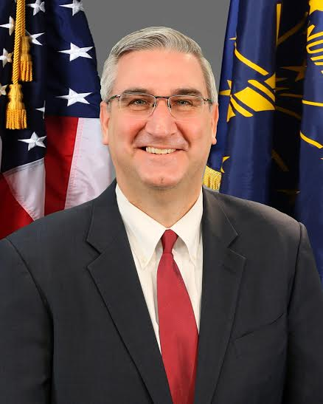

Eric Holcomb is the 51st Governor of Indiana.

A lifelong Hoosier, Gov. Holcomb is a veteran of the United States Navy, served as the state’s 51st Lt. Governor, was a trusted advisor to both Governor Mitch Daniels and Senator Dan Coats, and was a former state chairman of the Indiana Republican Party.

He was elected governor in November 2016, following an unprecedented 106-day campaign and was sworn in on January 9, 2017.

Already, Gov. Holcomb is moving our state forward. He led the way for the largest long-term infrastructure investment in our state’s history with the 20-year Next Level Roads program, which will invest $4.7 billion for roads and bridges in the first five years alone. To meet our state’s rapidly changing workforce needs, he unveiled the Next Level Jobs program to help get more Hoosiers into high-demand, high-wage jobs.

In his first legislative session as governor, he rallied bipartisan support from Indiana lawmakers to expand pre-K for low-income Hoosier kids, and he unveiled Next Level Recovery—a one-stop shop for information and resources on the state’s comprehensive and community-based effort to fight the opioid crisis. All of this work is underscored by Gov. Holcomb’s commitment to providing great government service for Hoosier taxpayers.

He has a mission to make Indiana competitive in the global economy by “bringing the world to Indiana and taking Indiana to the world.” So far, the governor has met with officials and industry leaders in the United Kingdom, Japan, Hungary, France, and more to showcase Indiana’s assets and build global economic ties.

Throughout his career in service, he has earned a reputation of being a consensus builder. He has traveled extensively throughout the state—talking with folks wherever he goes about how to make Indiana an even better place to live, work and play. A lifelong basketball fan, Gov. Holcomb has shot and made a basket in each of Indiana’s 92 counties.

The governor is a graduate of Pike High School in Indianapolis and Hanover College in southeastern Indiana where he majored in U.S. History with a focus on the American Civil War and the Reconstruction Era. He is a collector of presidential signatures and currently has documents signed by 42 of our nation’s 44 presidents.

He and his wife, Janet, live with their dog, Henry, in the Governor’s Residence on North Meridian Street in Indianapolis.